VIRTUAL PYTHON DATA EXPLORER INTERN
Advanced Data Exploration and Visualization
Internship: Virtual Python Data Explorer Intern
Internship Duration: 23-Aug-2026 to 20-Sep-2026
Task: Week 3 – Advanced Data Exploration and Visualization
Dataset: Campus Recruitment / Student Placement Dataset
Tools Used: Python, Pandas, NumPy, Matplotlib, Seaborn, SciPy
GitHub Repository: https://github.com/navya-23568/python-data-explorer-yuvaintern

1. Executive Summary
This Week 3 report presents an advanced exploratory data analysis of the student placement dataset prepared during Week 2. While Week 2 focused primarily on data acquisition, preparation, cleaning, and preliminary analysis, Week 3 extends the work toward deeper pattern recognition, relationship analysis, advanced visualization, and hypothesis-oriented statistical analysis.
The dataset contains academic, demographic, employability, specialization, placement, and salary-related attributes. The analysis uses Python-based data visualization and statistical techniques to investigate how these variables are related to placement outcomes. Matplotlib and Seaborn are used to create correlation heatmaps, box plots, bar charts, scatter plots, and distribution visualizations, while SciPy is used for statistical hypothesis testing.
The analysis goes beyond simply presenting numerical results. Each major visualization is interpreted in terms of the pattern observed, the strength and meaning of the relationship, possible real-world explanations, and limitations. Particular attention is given to academic performance, work experience, MBA specialization, placement status, and salary.
The findings indicate that academic performance variables show meaningful differences between placed and not-placed students. Work experience and specialization also reveal notable differences in observed placement outcomes. Correlation analysis helps identify which numerical variables have stronger relationships with placement, while hypothesis testing provides statistical evidence for selected observations. However, the analysis recognizes that association does not imply causation and that the dataset should not be used to make unsupported predictions about individual students.
This report also incorporates the feedback received during Week 2, which recommended adding greater depth to the analysis and interpretation of findings. Accordingly, the Week 3 analysis connects visual evidence with statistical results and practical implications rather than treating visualizations as standalone outputs.

2. Week 2 to Week 3 Continuity
2.1 Progression from Week 2
The Week 3 analysis is a direct continuation of the data preparation and preliminary analysis performed during Week 2. In Week 2, the dataset was acquired, examined, cleaned, structured, and used for initial descriptive analysis. Basic patterns related to placement status, academic performance, gender, work experience, specialization, and salary were identified.
Week 3 builds on this prepared dataset instead of repeating the acquisition and cleaning process. The objective is to investigate the previously observed patterns in greater depth using advanced exploratory techniques and statistical methods.
The progression can therefore be summarized as:
Week 2:
Data Acquisition → Data Preparation → Cleaning → Preliminary Analysis

Week 3:
Prepared Dataset → Advanced EDA → Visualization → Correlation Analysis → Hypothesis Testing → Deeper Interpretation
2.2 Addressing Week 2 Feedback
The Week 2 evaluation awarded a score of 62.6/100 and indicated that the report was thorough and well structured but recommended greater depth in the analysis and interpretation of findings.
This feedback has been incorporated into the Week 3 methodology. Instead of only reporting percentages or describing what a chart displays, the current report evaluates the magnitude of differences, compares patterns across variables, considers possible explanations, discusses statistical evidence, identifies practical implications, and clearly states analytical limitations.
This approach ensures that the visualizations are used as analytical tools rather than simply as decorative elements.

3. Dataset Overview
Dataset has the student placement information we already worked with.
Use:
Category | Description
Dataset type | Student/Campus Placement Dataset
Records | 215 students
Variables | 15 original attributes
Target outcome | Placement Status
Numerical attributes | SSC, HSC, Degree, E-test, MBA percentages, Salary
Categorical attributes | Gender, boards, streams, degree type, work experience, specialization
Placement categories | Placed / Not Placed
The dataset includes variables such as gender, SSC percentage, HSC percentage, HSC stream, degree percentage, degree type, work experience, employability-test percentage, MBA specialization, MBA percentage, placement status and salary. Your Week 2 dataset content confirms these field.
Explanation:
The placement status variable is treated as the primary outcome for the majority of the analysis. Numerical academic variables are examined using correlation and distribution-based techniques, while categorical variables are compared using grouped visualizations and statistical tests.
Salary requires separate treatment because it is recorded for placed students and is unavailable for students who were not placed. Therefore, missing salary values are not interpreted as zero salary.

4. Advanced Analysis Objectives
The primary objective of this Week 3 analysis is to move beyond preliminary descriptive analysis and perform advanced exploratory data analysis on the prepared student placement dataset. The analysis focuses on identifying meaningful relationships, patterns, trends, and differences between groups using statistical techniques and advanced visualizations.
The major objectives of the Week 3 analysis are:

- To identify stronger relationships among academic and placement-related variables.
- To examine correlations between numerical variables and placement outcomes.
- To compare score distributions between placed and not-placed students.
- To identify meaningful patterns using advanced visualizations.
- To investigate the relationship between work experience and placement.
- To examine placement differences across MBA specializations.
- To study relationships between different academic performance indicators.
- To analyse salary distribution among placed students.
- To perform hypothesis tests for selected relationships.
- To interpret visual and statistical findings in a real-world context.
- To identify limitations and avoid unsupported causal conclusions.

5. Visualization Strategy
A visualization strategy was developed to ensure that each chart addresses a specific analytical question. Instead of creating visualizations only for presentation purposes, each visualization is selected based on the type of variable and the relationship that needs to be investigated
Visualization | Purpose
Correlation Heatmap | Identify relationships between numerical variables
Box Plot | Compare distributions and detect spread/outliers
Bar Chart | Compare placement rates across categories
Scatter Plot | Identify relationships between academic variables
Histogram/Distribution Plot | Understand salary and score distributions
Grouped Analysis | Compare placed and not-placed populations
Then add:
The visualization strategy was designed to match the analytical question rather than using charts arbitrarily. Heatmaps are appropriate for correlation screening, box plots are useful for comparing distributions, bar charts provide direct categorical comparisons, and scatter plots help identify relationships between continuous variables. This combination provides both univariate and multivariate perspectives on the dataset.
6. Data Preparation and Transformation
The dataset prepared during Week 2 was reused for the advanced analysis in Week 3 to maintain consistency and reproducibility. Before generating advanced visualizations and conducting statistical tests, the dataset was inspected to ensure that numerical variables were stored in an appropriate format and that the placement outcome could be analysed quantitatively.
The main numerical variables considered for advanced analysis were SSC percentage, HSC percentage, Degree percentage, Employability Test percentage, MBA percentage, and Salary. Placement Status was transformed into a binary analytical variable, where “Placed” was represented as 1 and “Not Placed” as 0. This transformation allows correlation and statistical analysis to be performed using the placement outcome.
Salary was treated separately because salary information is available only for students who were placed. Missing salary values corresponding to students who were not placed were therefore not replaced with zero, as doing so would incorrectly imply that these students received a salary of ₹0.
The prepared dataset was then used for correlation analysis, distribution analysis, categorical comparisons, visualization, and hypothesis testing.

7. Advanced Visualization Strategy
The visualization strategy was designed to move beyond basic descriptive analysis and identify deeper patterns in campus placement outcomes. Different visualization techniques were selected according to the type of variable and the analytical question being investigated.
Box plots were used to compare the distribution of academic and employability scores between placed and non-placed students. These plots help identify differences in central tendency, spread, and potential outliers.
Bar charts were used for categorical comparisons, including placement outcomes by work experience, MBA specialisation, gender, HSC stream, and degree type. Percentage-based visualizations were preferred for categorical groups because they allow meaningful comparison even when group sizes differ.
Correlation heatmaps were used to examine relationships among numerical academic and employability variables. A separate correlation analysis was also performed after encoding placement status numerically to examine its association with key performance measures.
A salary distribution plot was created using only placed students with available salary information. This avoided incorrectly treating missing salary values for non-placed students as zero.
Statistical hypothesis tests were also incorporated to support the visual findings. An independent-samples t-test was used to compare SSC performance between placement groups, while a chi-square test of independence was used to examine the relationship between work experience and placement status.

8. Advanced Exploratory Data Analysis
8.1 Placement Status Distribution
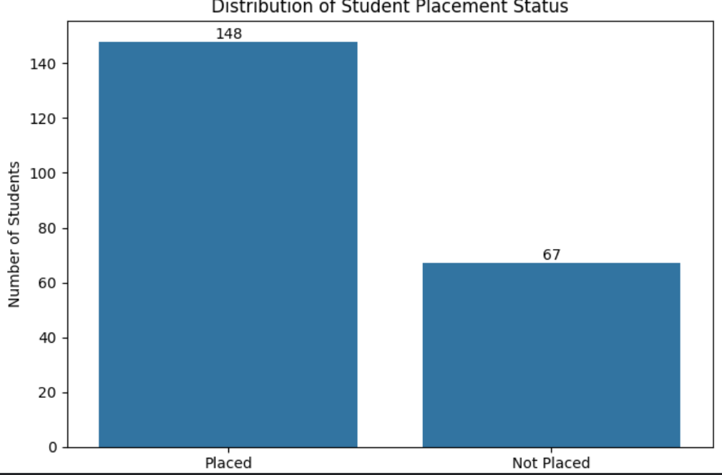
The placement-status distribution shows that the dataset contains more placed students than non-placed students. Out of 215 students, 148 students were placed, while 67 students were not placed. This corresponds to a placement rate of approximately 68.84%. The imbalance between the two groups is important for subsequent analysis because placement status is the main outcome variable. The remaining analyses therefore compare academic performance, work experience, specialisation, and other student characteristics across these two groups

8.2 SSC Performance by Placement Status

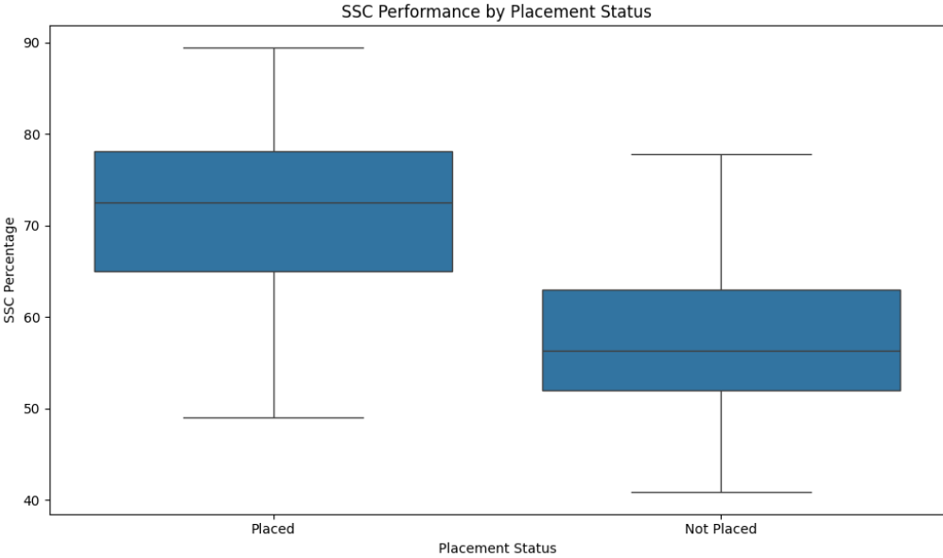
Figure 2: SSC Performance Distribution by Placement Status
The box plot compares SSC percentage distributions between placed and non-placed students. It shows that placed students generally have higher SSC performance than non-placed students. The median SSC percentage of the placed group is higher, indicating that stronger secondary-school academic performance is associated with a better placement outcome in this dataset. The spread of scores also shows that placement is not determined by SSC performance alone, because there is considerable overlap between the two groups. Therefore, SSC performance appears to be an important factor, but it should be considered together with other academic and non-academic variables

8.3 HSC Performance by Placement Status
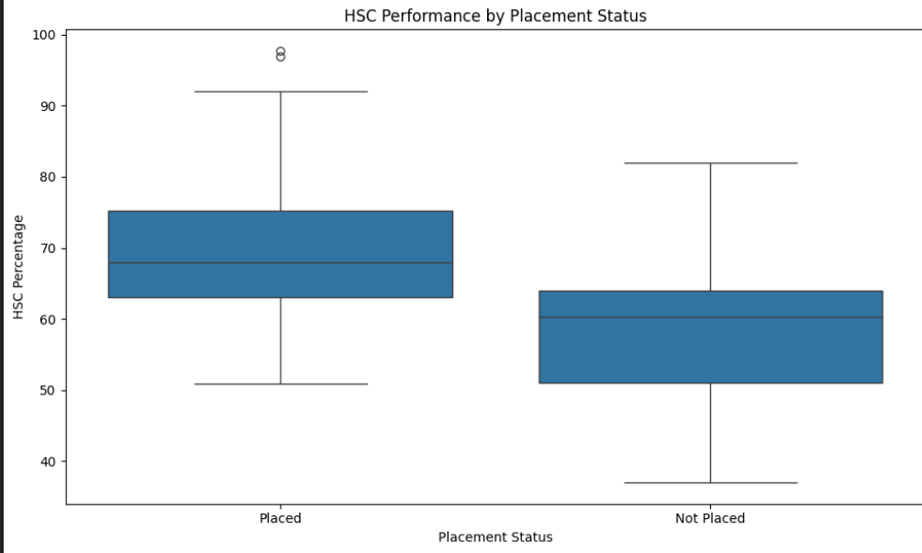
The box plot compares HSC percentage distributions between placed and non-placed students. The placed group generally shows higher HSC performance, with a higher central tendency than the non-placed group. This indicates a positive association between higher HSC performance and placement outcome in the dataset. However, the overlap between the two groups demonstrates that HSC performance alone does not determine placement success. Other factors such as degree performance, employability test scores, work experience, and specialisation also need to be considered.

8.4 Degree Performance by Placement Status
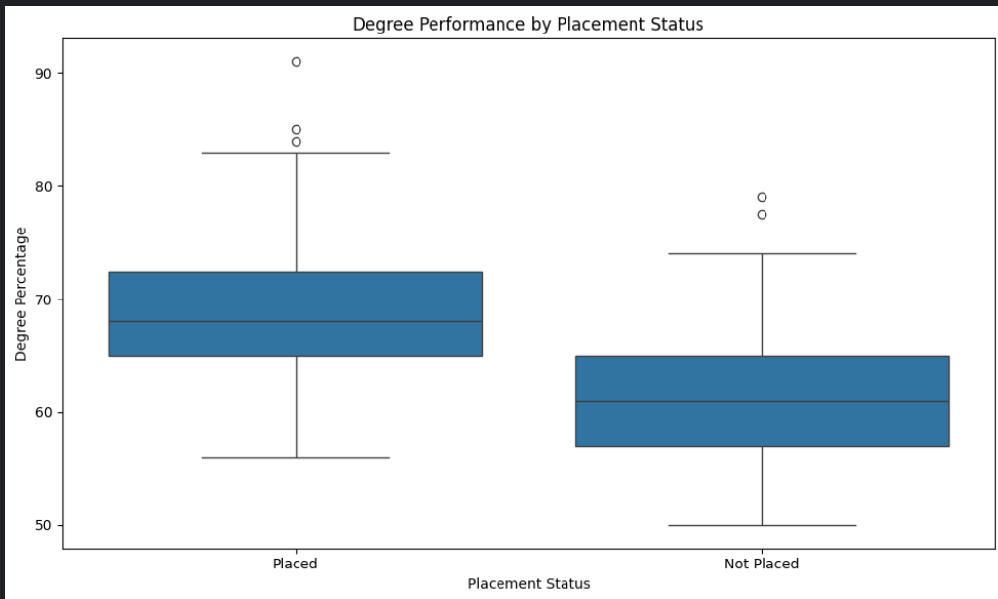
The box plot compares degree percentage distributions between placed and non-placed students. Placed students generally show higher degree performance than non-placed students, indicating a positive association between undergraduate academic performance and placement outcome. Although the distributions overlap, the difference in their central tendencies suggests that degree performance is relevant to placement outcomes. However, academic performance alone cannot fully explain placement success, as other factors also contribute to the final placement result.

8.5 Employability Test Performance by Placement Status

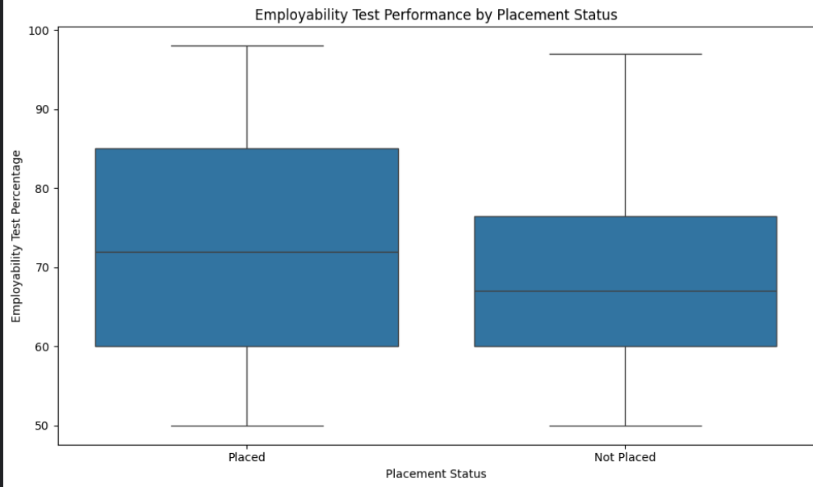
Placement outcomes differ between the two MBA specialisations. Mkt&Fin shows a higher placement rate than Mkt&HR in this dataset. This difference may reflect variations in employer demand, student profiles, or recruitment opportunities. The result should be interpreted as a dataset-specific association rather than evidence that one specialisation guarantees better placement opportunities.

8.6 Placement Rate by Work Experience
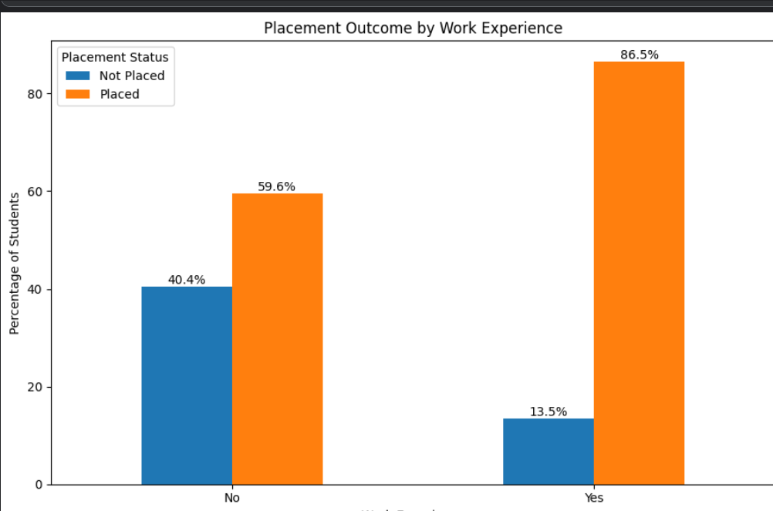
Figure 6: Placement Rate by Work Experience
Students with previous work experience show a higher placement rate than students without work experience. This suggests that practical exposure may be associated with improved placement outcomes. The difference is particularly relevant because employers may value prior professional exposure. However, this relationship represents an association and should not be interpreted as proof of causation.

8.7 Placement Rate by MBA Specialisation
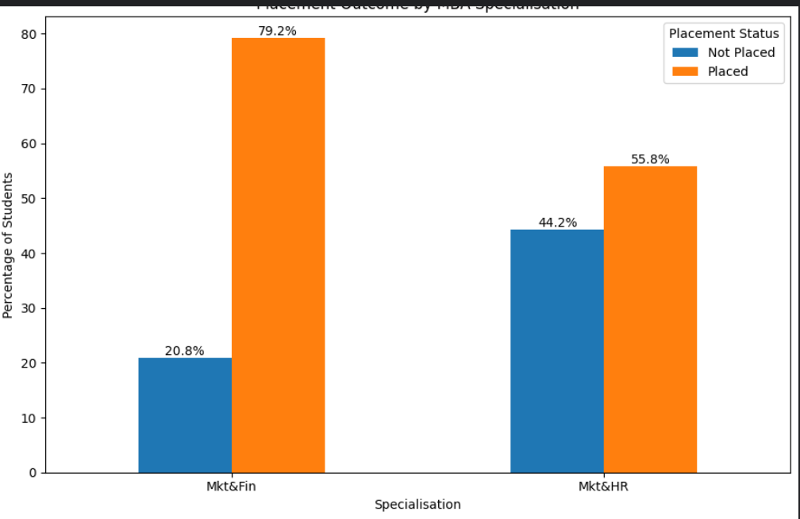
Figure 7: Placement Rate by MBA Specialisation
Placement outcomes differ between the two MBA specialisations. Mkt&Fin shows a higher placement rate than Mkt&HR in this dataset. This difference may reflect variations in employer demand, student profiles, or recruitment opportunities. The result should be interpreted as a dataset-specific association rather than evidence that one specialisation guarantees better placement opportunities

8.8 Placement Rate by Gender
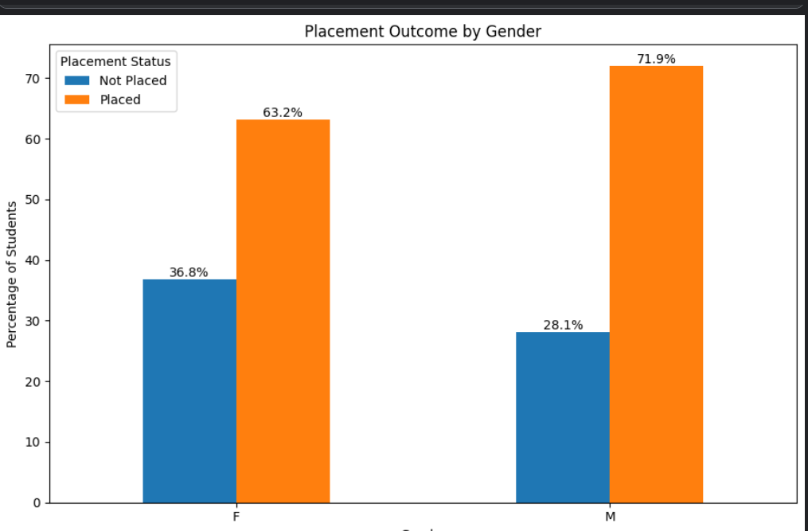

Figure 8: Placement Rate by Gender
The visualization compares placement rates between male and female students. Differences can be observed between the groups, indicating variation in placement outcomes by gender within this dataset. However, the analysis should not be interpreted as evidence that gender directly determines placement because other variables such as academic performance, work experience, and specialisation may also influence the outcome.

8.9 Placement Rate by HSC Stream
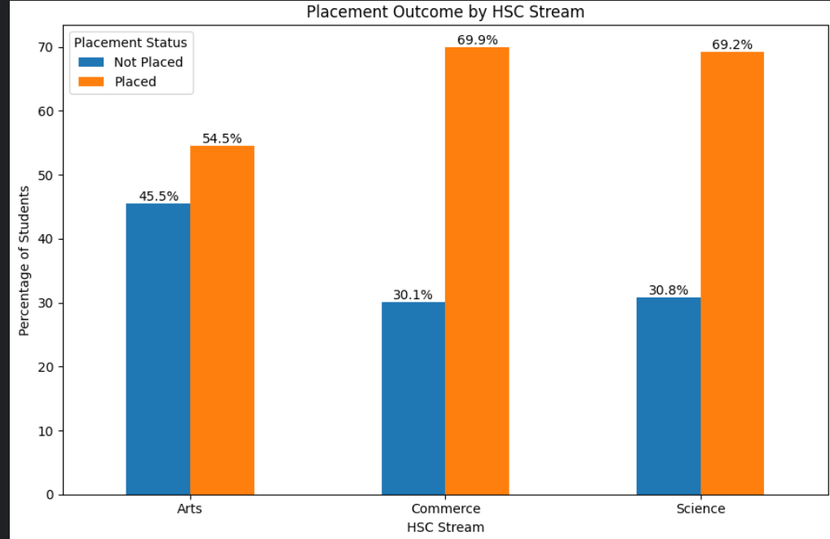
Figure 9: Placement Rate by HSC Specialisation
The analysis compares placement outcomes across different HSC streams. The visualization shows that placement rates vary between streams. These differences may reflect differences in student academic backgrounds and subsequent degree choices. Since the dataset is limited to a specific placement context, the observed differences should not be generalized to all students or institutions.

8.10 Placement Rate by Degree Type
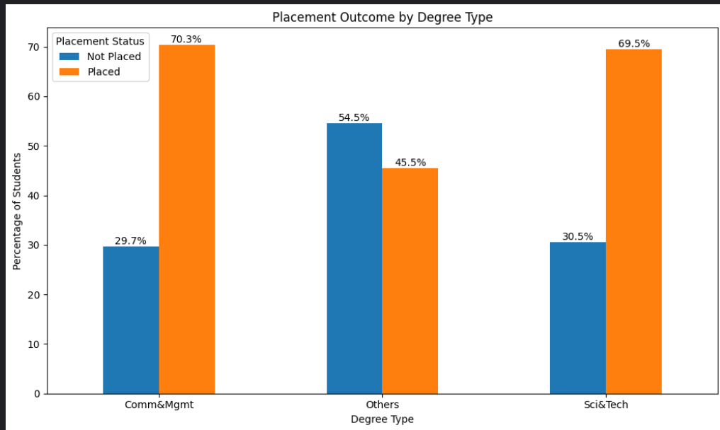
Figure 10: Placement Rate by Degree Type
Placement outcomes vary across different undergraduate degree types. The visualization helps identify whether students from particular degree backgrounds have different placement proportions. Such differences may be related to the types of companies participating in campus recruitment and their preferred educational backgrounds. Further analysis with larger datasets would be required to determine whether these patterns are consistent

8.11 Salary Distribution of Placed Students
Figure 11: Salary Distribution Among Placed Students
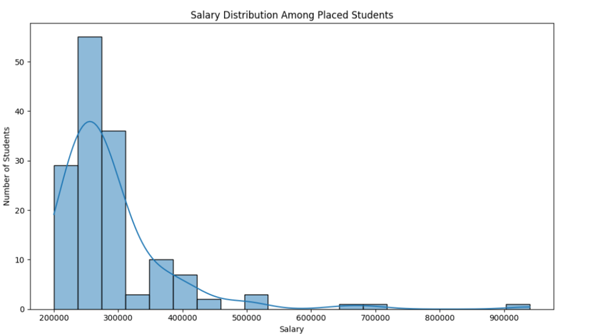Salary analysis was performed only for students with recorded salary information, which corresponds to placed students. The distribution shows variation in salaries among successful candidates. The average salary among placed students is approximately ₹288,655. The variation indicates that placement success does not necessarily result in identical compensation and that salary outcomes depend on the recruiting organization, role, student profile, and other factors.

8.12 Placement Outcome by Gender and Work Experience
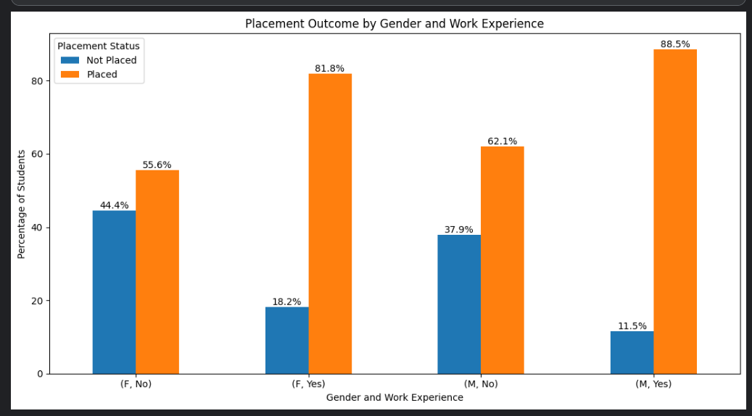
Figure 12: Placement Outcome by Gender and Work Experience
The grouped analysis examines placement outcomes across combinations of gender and prior work experience. The results indicate that placement proportions vary across these groups, suggesting that work experience and gender may show different placement patterns when considered together. The relatively small dataset means that these differences should be interpreted cautiously.

8.13Correlation Among Academic Performance Variables
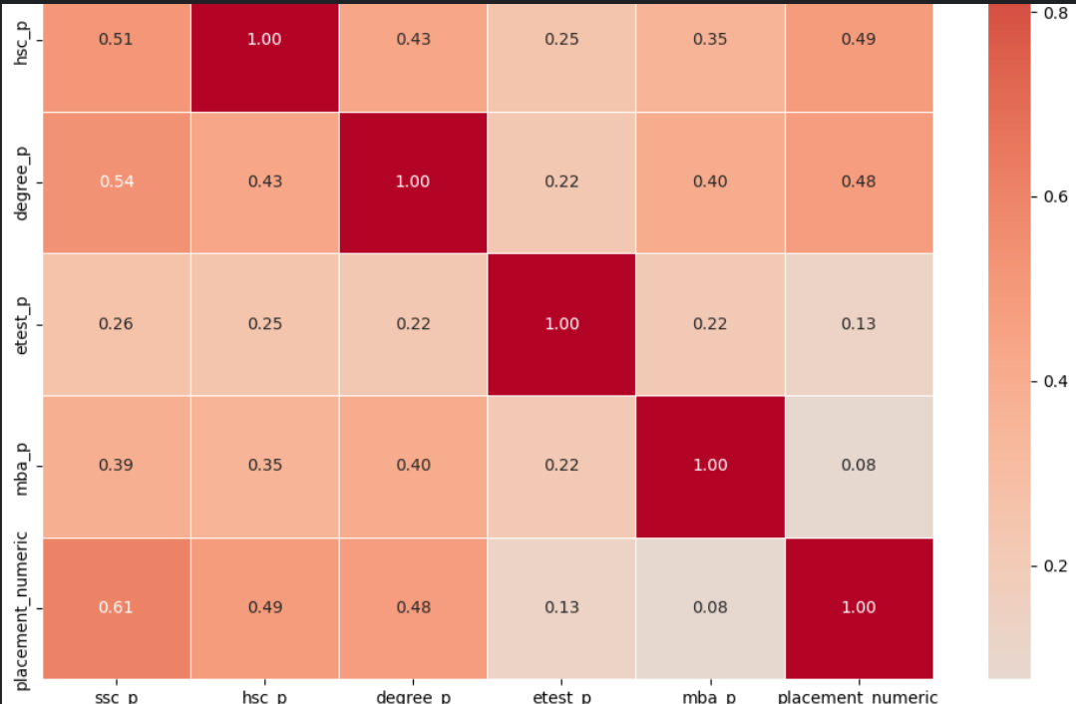
Figure 13: Correlation Heatmap of Academic and Employability Variables
The correlation heatmap shows relationships among SSC, HSC, degree, employability test, and MBA percentages. Positive relationships between several academic variables indicate that students who perform well in one academic stage may also tend to perform well in other stages. The strength of these relationships provides useful information about the structure of the dataset and helps identify variables that may contain related information.

8.14 SSC Performance and Placement — Statistical Test
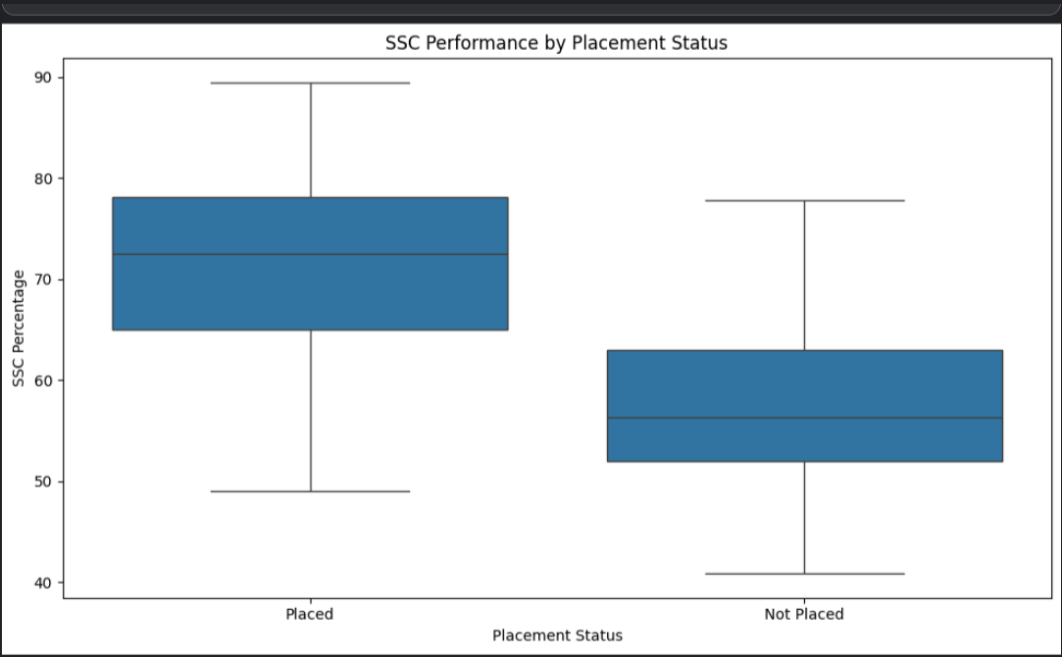
Figure 14: SSC Performance Comparison for Hypothesis Testing
An independent-samples t-test was conducted to examine whether SSC scores differed significantly between placed and non-placed students. The test produced a t-statistic of 11.3332 with a p-value below 0.001. Therefore, the null hypothesis was rejected. The result indicates a statistically significant difference in SSC scores between the two placement groups. This supports the visual observation that SSC performance differs between placed and non-placed students.
Statistical result:
- T-statistic: 11.3332
- P-value: < 0.001
- Decision: Reject the null hypothesis

9. Statistical Analysis and Hypothesis Testing
The statistical analysis was conducted to complement the visual exploration and determine whether selected differences and associations were statistically significant. An independent-samples t-test was used to compare SSC scores between placed and non-placed students. A chi-square test of independence was used to examine the association between work experience and placement status.

The t-test produced a statistic of 11.3332 with a p-value below 0.001, indicating a statistically significant difference in SSC scores between the two groups. The chi-square test produced a statistic of 15.1544 with 1 degree of freedom and a p-value of approximately 0.000099, indicating a statistically significant association between work experience and placement status.

These results strengthen the observations obtained from the visual analysis. However, statistical significance should not be interpreted as proof of causation.
10. Key Findings
Key Findings from Advanced Analysis
- The dataset contains 215 student records and 15 variables.
- A total of 148 students were placed, while 67 students were not placed, giving an overall placement rate of approximately 68.84%.
- Box-plot analysis shows that placed students generally have higher SSC, HSC, degree, employability test, and MBA percentages than non-placed students.
- The correlation analysis shows positive relationships among several academic performance variables. This indicates that academic performance measures are not completely independent of one another.
- Work experience shows a clear difference in placement outcomes. Students with work experience have a higher placement proportion than students without work experience.
- The chi-square test confirmed a statistically significant association between work experience and placement status (χ² = 15.1544, p < 0.001).
- The independent-samples t-test found a statistically significant difference in SSC scores between placed and non-placed students (t = 11.3332, p < 0.001).
- MBA specialisation also shows differences in placement outcomes, with Mkt&Fin showing a higher placement proportion than Mkt&HR in this dataset.
- Salary analysis was restricted to placed students because salary information is unavailable for non-placed students. The salary distribution demonstrates variation in compensation among successfully placed students.
10.The combined visual and statistical evidence indicates that placement outcomes are associated with multiple academic and non-academic characteristics rather than a single factor.
11.The findings represent associations within this dataset and should not be interpreted as proof that any individual factor directly causes placement success.
11.Discussion and Interpretation
The advanced exploratory analysis provides a deeper understanding of factors associated with campus placement outcomes. The visualizations consistently show that placed students tend to perform better across several academic and employability measures. Rather than relying on a single variable, the analysis demonstrates the importance of examining the student's overall profile.
The box plots provide evidence that the distributions of SSC, HSC, degree, employability test, and MBA scores differ between placement groups. The correlation heatmap further shows relationships among the academic variables, suggesting that students who perform well academically often demonstrate relatively strong performance across multiple stages of education.
Work experience emerged as an important categorical factor. Students with previous work experience showed a higher placement rate, and the chi-square test confirmed that the association between work experience and placement status was statistically significant. This suggests that practical exposure may be relevant to placement outcomes, although the analysis cannot establish a causal relationship.
The SSC hypothesis test also produced a statistically significant result. This means that the observed difference in SSC scores between placed and non-placed students is unlikely to be explained by random sampling variation alone under the assumptions of the test.
Specialisation analysis showed differences between Mkt&Fin and Mkt&HR placement outcomes. However, these differences should be interpreted in the context of employer demand, student preferences, academic performance, and other characteristics.
Overall, the results support a multidimensional view of campus placement. Academic achievement, employability performance, practical experience, and specialisation may all contribute to differences in placement outcomes. Statistical significance should not be confused with causation, and further analysis using larger and more representative datasets would be required to establish predictive or causal relationships.
12.Recommendations
Based on the findings, the following recommendations can be considered:
- Students should maintain consistent academic performance across SSC, HSC, degree, and MBA levels.
- Students should participate in internships, projects, and other activities that provide practical exposure and work-related experience.
- Employability-test preparation should be included in placement preparation because employability performance differs across placement groups.
- Career guidance can help students understand how different specialisations may align with employer requirements.
- Placement preparation should not focus exclusively on academic marks. Communication skills, practical experience, technical skills, aptitude preparation, and interview readiness should also be developed.
- Institutions can use historical placement data to identify groups that may benefit from targeted training and career-support programs.
- Future analysis should use larger datasets from multiple institutions and recruitment cycles to improve the reliability and generalisability of the findings.
13.Limitations
The analysis has several limitations. First, the dataset contains only 215 student records, which limits the generalisability of the findings. Second, the data represents a particular campus-placement context and may not represent students from other institutions, regions, or recruitment periods.
The analysis identifies associations rather than causal relationships. Statistical significance does not prove that a particular variable directly causes placement success. In addition, salary information is available only for placed students, so salary comparisons between placed and non-placed students are not appropriate.
Some categorical groups may also contain relatively fewer observations, which can make percentage-based comparisons less stable. Future work could address these limitations by using larger, more diverse datasets and applying multivariate statistical or machine-learning techniques.

14. Conclusion
The Week 3 advanced analysis provided a deeper understanding of the factors associated with campus placement outcomes. Through visualization, correlation analysis, and statistical hypothesis testing, the study identified meaningful differences between placed and non-placed students. Academic performance measures, employability test performance, work experience, and specialisation showed important associations with placement outcomes.
The statistical tests further supported selected observations, particularly the significant difference in SSC scores and the significant association between work experience and placement status. Overall, the analysis demonstrates that campus placement is a multidimensional outcome that cannot be explained by a single variable. The findings provide useful insights for students and institutions while also highlighting the need for larger and more representative datasets in future studies.

